# Go调用智能合约

## ****一、安装geth****

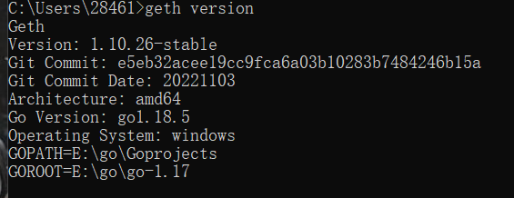

## ****二、Geth私有链搭建****

### ****1.创建genensis.json文件，放在geth所安装的目录****

{

"config": {

"chainId": 15,

"homesteadBlock": 0,

"eip150Block": 0,

"eip150Hash": "0x0000000000000000000000000000000000000000000000000000000000000000",

"eip155Block": 0,

"eip158Block": 0,

"byzantiumBlock": 0,

"constantinopleBlock": 0,

"petersburgBlock": 0,

"istanbulBlock": 0,

"ethash": {}

},

"nonce": "0x0",

"timestamp": "0x5ddf8f3e",

"extraData": "0x0000000000000000000000000000000000000000000000000000000000000000",

"gasLimit": "0x47b760",

"difficulty": "0x00002",

"mixHash": "0x0000000000000000000000000000000000000000000000000000000000000000",

"coinbase": "0x0000000000000000000000000000000000000000",

"alloc": { },

"number": "0x0",

"gasUsed": "0x0",

"parentHash": "0x0000000000000000000000000000000000000000000000000000000000000000"

}

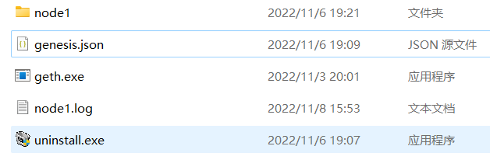

### ****2.初始化区块链****

geth init --datadir node1 genesis.json //"--datadir"是指定数据存放的目录，例如node1

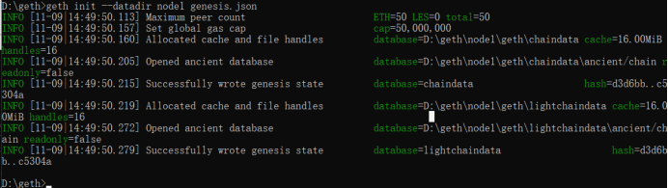

Successfully ancient database 代表geth初始化成功

### ****3.启动私有节点****

geth --datadir "xxxx" --networkid ???? --port ????? --http --http.api "eth,net,web3,miner,admin" --http.addr "localhost" --http.port ???? console --nodiscover 2>node1.log

geth --datadir "node1" --networkid 6666 --port 10010 --http --http.api "eth,net,web3,miner,admin,personal" --http.addr "localhost" --http.port 8545 --http.corsdomain https://remix.ethereum.org --allow-insecure-unlock console 2>node1.log

（1）--networkid后面跟数字，表示指定这个私有链的网络id。以太坊公网的网络id是1，为了不与公有链网络冲突，运行私有链节点的时候要指定自己的网络id并且不能为1；

（2）2>node1.log就是将日志信息输出到当前目录下的output.log的文件里；

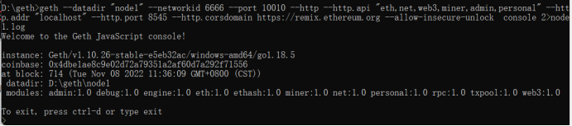

（3）运行节点时，--http.corsdomain https://remix.ethereum.org让节点可以连接remix，进行合约调用，但超过字节限制的合约是无法挖矿成功，以至于无法部署。

（4）remix连接端口

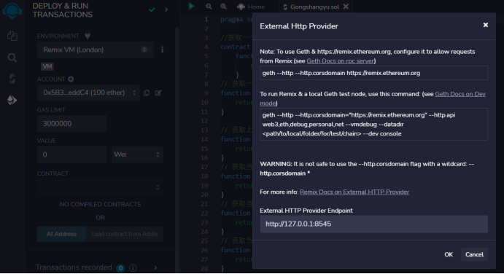

这里我已经创建了两个用户，并一个用户进行了挖矿



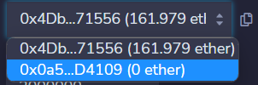

部署合约时账户是锁住的，需要解锁



正在挖矿

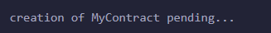

学习误区：一直未挖矿成功

### ****4.账户交易****

#### 创建用户

Personal.newAccount(“xxx”)

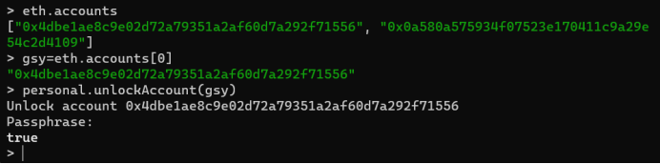

查询当前节点下所有的账户

eth.accounts

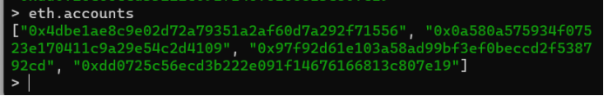

#### 挖矿操作

开始挖矿：miner.start()或者miner.start（X）

确认挖矿状态：eth.mining

停止挖矿：miner.stop()

设置挖矿账户miner.setEtherbase(accounts[?])

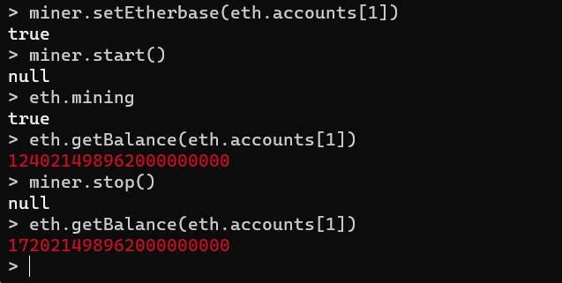

#### 查看区块和余额

eth.blockNumber

eth.getBalance(eth.accounts[0])//这里的accounts[0]就是我们创建的第一个账户

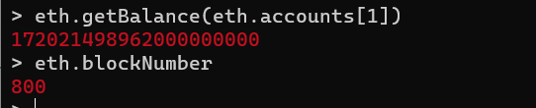

#### 转账交易

解锁账户:personal.unlockAccount(eth.accounts[?]);

转账:eth.sendTransaction({from: eth.accounts[?], to: eth.accounts[?],value: web3.toWei(?,"ether")})

查看交易:txpool.status

查看交易详情:txpool.inspect.pending

挖矿交易:miner.start(1);admin.sleepBlocks(1);miner.stop();

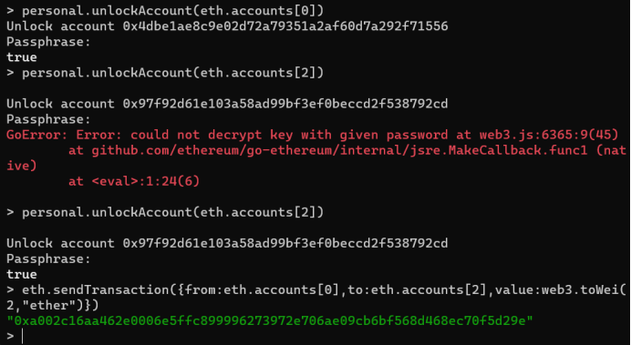

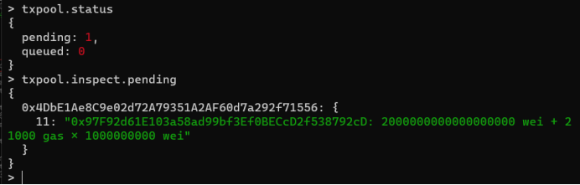

## ****三、使用abigen将智能合约转为go****

### 1.使用solcjs 生成abi 和 bin



### 2.使用abigen将上诉两个文件转go

abigen --bin demo_sol_MyContract.bin --bin demo_sol_MyContract.abi --pkg main --type Demo --out demo.go



### 3.使用创建账户



### 4.部署调用智能合约

package main

import (

"context"

"fmt"

"github.com/ethereum/go-ethereum/accounts/abi/bind" "github.com/ethereum/go-ethereum/ethclient"

"log"

"math/big"

"strings"

"time"

)

const keyinfo = `{"address":"46e3c75ae47f31abd24b2aef3c3fcf54d9636698","crypto":{"cipher":"aes-128-ctr","ciphertext":"b5665917f5df5dfd077d8d90f17b0abde36d8bb77d67302ddf76c7bf494d8c4c","cipherparams":{"iv":"8b6b3aa5ceec9559575044dbb853ff6e"},"kdf":"scrypt","kdfparams":{"dklen":32,"n":4096,"p":6,"r":8,"salt":"2cfde8437bcf959a31d7d0b0b07b8f922815c52fa5138ba6585d88a1b6eb529a"},"mac":"69f1140b51f2caec6fbb883663d1c67fecb3f55cc33464eb93a15f8945790f9c"},"id":"eda461d9-ddcb-4694-9345-d6dddc569f3e","version":3}`

func main() {

//1.创建客户端

cli,err := ethclient.Dial("http://127.0.0.1:8545")

if err != nil {

log.Panic("failed to Dial",err)

}

//2.身份准备

keyin := strings.NewReader(keyinfo)

ChainID,err := cli.ChainID(context.Background()) auth,err1 :=bind.NewTransactorWithChainID(keyin,"123",ChainID)

if err1 != nil {

log.Panic("failed to NewTransctor",err1)

}

//3.部署第二个合约

addr,tx,instance,err2:= DeployDemo(auth,cli)

if err2 != nil {

log.Panic("failed to Deploy Coupon2",err2)

}

fmt.Println("addr:",addr.Hex())

fmt.Println("tx:",tx.Hash())

msg , err3 := instance.GetBlockNumber(&bind.CallOpts{Pending: true})

if err3 != nil {

log.Panic("failed",err3)

}

fmt.Println(msg)

msg1 , err4 := instance.GetBlockHash(&bind.CallOpts{Pending: true},big.NewInt(1072))

if err4 != nil {

log.Panic("getBlockhash failed",err4)

}

fmt.Println(msg1)

fmt.Printf("TX start @:%s", time.Now())

}

